huntington county democratic party PRESENTS:

the blue news
  - Volume 2/ Issue 3 March 10, 2021
upcoming events:
March 13, Noon, District 3 Reorganization Meeting
March 15, Pampered Chef party begins.
March 20, State Party Reorganization Meeting
March 26, Delivery food donations
March 1-31, Food Pantry Drive
March 29, Pampered Chef party ends
April 1, Project Rebuild Candidate Call-Out Zoom (see Facebook for link)
April 4, Easter
April 12, HCDP Monthly Meeting, UAW Hall, Roanoke

HAPPY WOMEN’S MONTH! LET’S ENJOY AND EMBRACE OUR ACCOMPLISHMENTS AND LIFT EACH OTHER UP!

CARDS TO SENIORS PROJECT COMPLETE
The HCDP members sent a total of 587 cards to our Senior community members. THANK YOU!

HCDP DEMOCRAT OF THE YEAR AWARD:
The Democrat of the Year award has arrived and will be presented at our April in-person meeting. Please try to make this meeting at the UAW Hall on April 12 @ 6:30 p.m.
HCDP REORGANIZATION HELD ON MARCH 6
As required by the Indiana Democratic Party (INDEMS) By-Laws, the reorganization meeting was held March 6 at 10:00 a.m.
We have 40 voting members and 33 were in attendance. Election results: Chair, Christine Bohm, 32 votes 1 abstention (her husband did not vote due to nepotism);Vice Chair, Brian Humphries, 32 votes, Brian abstained; Secretary, Cynthia Hyde, 33 votes; Treasurer, Bill Oswalt 32 votes, Bill abstained.
We want to send a huge THANK YOU to Pat McCloskey for her work as our previous Vice Chair and most recently, Secretary!
PAMPERED CHEF PARTY SCHEDULED
Mary Ellen Neuenschwander, Deputy Chair of Fundraising, has arranged for the HCDP to host an online Pampered Chef party. 25% of the proceeds are earned by the party. The link to this online event will be shared via Social media, email, and text. Please feel free to share with all of your friends.
MARCH COMMUNITY SERVICE EVENT
Our community service event for March is collecting donations for local food pantries. Please contact Christine if you have donations.

“There is no limit to what we, as women, can accomplish”, Michelle Obama.

PAGE 2 VOL 2/ ISSUE 3

SAVE YOUR PLASTIC LIDS PLEASE!
We are collecting lids to have them turned into a Buddy Bench. Please read the article below for the details. We are extremely excited about this project! UPDATE: We have already gathered 10 moving boxes of lids. PLEASE continue to collect them. The Bohm house can be a storage area until we have enough to get our first bench. https://www.scearthconnection.org/bottle-caps-to-benches/

WE STILL NEED PC’S IN HUNTINGTON 11, 11a, 12, JEFFERSON, SALAMONIE 1 (WARREN), SALMONIE 2 (WARREN) AND WAYNE
Contact Us
Huntington County Democratic Party
2915 E 630 N, Huntington, IN 46750
260-786-0701 (Christine Bohm, Chair)
huntingtondemchair@gmail.com
Facebook: https://www.facebook.com/groups/HuntingtonDemocraticParty
Twitter: @HuntingtonCoun1

Donation Link:
https://secure.actblue.com/donate/huntingtoncounty
If you would like to represent the above mentioned Precincts, please contact Christine for an appointment to the position. We are also in need of Vice PC’s in Huntington 1A, 2A, 3, 4, 5A, 6A, 7, 7A, 8, 10, 11, 11A, 12, 12A, Clear Creek 1 & 2, Dallas 1, Jackson 1, Jackson 4, Jefferson, Lancaster, Rock Creek, Salamonie 1 & 2, Warren (Bippus) and Wayne. A Vice PC helps the PC in contacting our Democrat voters. They work as a team to make sure all of our voters are aware of our party and who represents them.
NATIONAL FEDERATION OF DEMOCRATIC WOMEN & FW LEAGUE OF WOMEN VOTERS
Please consider joining these amazing groups! https://www.nfdw.com/membership https://lwvfw.org/
HCDP WOMEN’S COUNCIL IS OFFICIALLY FORMED AND I OWE YOU AN APOLOGY
With all of the reorganization activities this month, I haven’t fully completed the guidelines and plan for the Women’s Council. This will be completed as quickly as possible once all of the reorganization meetings are complete. We will be having our first meeting very soon! Please accept my apology for the delay in this outstanding Council!
The HCDP Women’s Council’s purpose is to promote women’s issues and celebrate the accomplishments of Outstanding Women throughout our community. We will be hosting a yearly Awards dinner in which 5 different areas of accomplishment will be recognized and to provide 2, $500 scholarships to local High School Seniors. This will be designed to be a NON-PARTISAN event. Congratulations and THANK YOU to the Dem Women who have stepped up to lead this initiative!
Lori Rice, Chair; Roxanna Lucas Murray, Vice Chair; Pamela Beckford, Treasurer; Erika Bruce, Amber Mellinger, Cynthia Wehr, Stephanie Tipton Martz, Joyce Bentz, Mary Ellen Neuenschwander, Sara Beaver and Carla MacDonald. We still need one of the appointed members to act as Secretary. All women of HCDP can be general members. Sorry guys, this one is for the members who identify as women only.
SUBCOMMITTEE’S STILL BEING FORMED:
As we continue to grow and reinvent our party, we would like to form a few additional committees to help lighten the burden for the Central Committee. We are looking for volunteers for an event planning committee, a fund-raising committee to be headed by Deputy Chair of Fund-raising, Mary Ellen Neuenschwander, and a candidate training and support committee. Briefly, we envision the committees to help in the following areas:

PAGE 3 VOL 2 / ISSUE 3
Event planning: parades, fireworks displays, candidate meet and greets, special monthly meetings, Blue Gala event, and other things of this sort.
Fund-raising: help plan and execute plans for different fund-raising opportunties. An example would be a baked potato sale, community garage sale, raffle ticketed events, etc. This is a wide-open field that we can have a lot of fun planning and hosting.
Candidate training and support: this could include helping candidates prepare for debates, helping craft messages that appeal to different demographics of the voting community, helping organize canvassing events, and other things necessary to insure a successful campaign.
If you are interested in volunteering for any of these committees, please reach out to Christine.
COOKIES FOR TEACHERS!
We collected cash donations in the amount of $250 for the purchase of Girl Scout Cookies to be given to our teachers as a “Thank You” from all of us to all of them! You Democrats really are the best!
BLUE ACRES
Greetings from The Acres! Whew, we made it through February, a tad chilly and a dusting of snow. Now that the snirt, snow/dirt, is gone and it is brown and muddy, life around the farm is getting busier. Time to start getting equipment ready; servicing tractors and implements, figuring out how much and what kind of seed to buy, getting soil samples tested so the amount of fertilizer can be calculated, ordered, and purchased. This is also the time of year that stored grain is sold. There is already increased farm equipment on the roads, soon to be a tractor jam. If you happen to be out and about on county roads, you see that mammoth green or red machine coming down the road, get out of the way. That monstrosity cannot stop on a dime, you will lose. That is a real fear for farmers. The roads are the only way to get to fields. Give the person driving the tractor a break.
I mentioned earlier, ”…give whoever a break,” that whoever can be women. March is Women’s History Month. Women have played an integral role on farms since the days of the pioneer woman, who was the original female farmer. Women’s roles in farming have varied over the centuries but have always been vital. Women in farming are becoming more involved in the daily operations as farms grow in acreage. Traditionally, women were not “allowed” to work the ground. There are always instances where that is not true but in general, women were not in the field other than to bring food. We were expected to stay at the house, tend to the children, and vegetable gardens, tending to the home property, inside and out, otherwise known as “woman’s work,” and in most cases, these same women had to work for a paycheck off the farm as well. We are also “parts runners” with little to no knowledge given of what the heck we are picking up, “…they know…” is what we are told. You can laugh at this; I do every time I go get parts. This one will really grab ya, ask any farmer’s wife if they control the weather? We never know the power we have until it rains too much or not enough. I say that in jest, but we are often sounding boards of the frustrations that come along with the life. Farming is not a job; it is a way of life.
Over the centuries, women were vital because if there was not a woman at home, there was not much of a home. There was not much a pioneer woman could NOT do on farms; from birthing livestock, plowing fields, tending gardens, children, and wildlife. That is not what a farmer is now. Women are becoming more prevalent in the traditional male roles. They are selling seed, managing the business end of farming, doing research and development (STEM), soil and conservation officers, working the ground in real tractors. We are taking on more in the area of agronomy, entomology, business management, and ground management to name a few. Ladies of farming, we are making strides in actual ownership as well. According to the US Census, “In 2017, the United States had 1.2 million female producers, accounting for 36 percent of the country's 3.4 million producers. Female producers are slightly younger, more likely to be a beginning farmer, and more likely to live on the farm they operate than male producers.” You know what this tells me, the tradition of giving the farm to namesake males of the family or the husbands of the daughters, is changing. More women are becoming
PAGE 4 VOL 2 / ISSUE 3

involved in the family operation, not just weeding, and feeding anymore. That is a trend we can all live with. The girls worked as hard as the boys on the farm. Girls deserve equal ability to take on ownership.
Not only are things getting busy outside of city limits, but it is also time to start thinking about developing urban farms. Scottie Thornsberry and Urban Blue Acres is here to inform us of the ins and outs of what urban farming is and can be.
Joyce—
URBAN ACRES
Gardeners and homesteaders all over the state of Indiana are preparing for the coming spring. Growing and raising food is such an important part of food independence and a key to escape poverty. Gardeners everywhere are slinging seed packs, tending to garden beds, and warming grow lights all to get the best start possible for their gardens. Having a successful garden can be crucial to many families who depend on growing their own food. Planning is a great way to make sure a garden will produce the best and correct foods to meet food needs.
Now is the time to inventory seed packs, secure seed starting mix, and gather as many growing containers as possible. I, personally, order most of my seeds from Baker Creek Heirloom Seeds, and MiGardener Seed company. I typically stick to organic heirloom seed companies, but I also am not afraid to use seeds from the Dollar Tree. Growing food should be accessible to all people and I encourage people to use what is affordable and obtainable.
In addition to growing a garden for security, raising animals can also provide food security. For those of us in urban settings rabbits and chickens are a great option for meat and egg production. However, being in Huntington has its limitations. Currently both animals are restricted to some level within city limits. Rabbits are permitted, but they cannot be sold or processed for food on property in town. Chickens are currently restricted to city lots that are at least five acres. Many are trying to petition to the city to reconsider urban backyard chicken keeping. Small flocks are completely manageable in small backyards.
There is a running petition that close to 500 city dwellers have signed to allow urban chickens into more backyards. The petition lays out a plan for up to six hens with a two square feet per bird coop requirement and ten square feet per bird of outdoor space. The petition also includes setback recommendations and cleanliness standards. Chickens and humans have had an exceptionally long symbiotic relationship. Chickens are also key component for individuals and families in poverty to be more food secure and to raise out of poverty. Chickens open many doors and should be included in urban homesteads and backyards.
I challenge each of you to start a garden no matter the size and become more food secure. I also encourage those that live in Huntington to reach out to your city council person and let them know that you support urban and backyard chickens! Let’s all be more food secure this year! Follow along my personal journey on YouTube: Broke Urban Farmer.
Scottie--

PAGE 5 VOL 2 / ISSUE 3
DISTRICT REORGANIZATION:
As with the County level org, the District is also conducting the required Re-organization on March 13. Current Chair Misti Meehan is not seeking re-election at this point. To date, 2 people have put their names in for this position. Christine Bohm, Huntington County Democratic Party Chairwoman and Lauro Zuniga, appointed Chair Indiana Young Democrats of CD3. If additional candidates arise, we will provide this information to you. The Chairs and Vice Chairs of the county parties are those who will cast their ballots for this position.
STATE PARTY REORGANIZATION:
The Indiana Democratic Party reorganizatoin meeting is scheduled for March 27. Trish Whitcomb and Mike Schmuhl have placed their names in for this position.
Only District Chairs, Vice Chairs and State Caucus members vote on the State Chair. Currently, the State Caucus’s are: College Dems, African American Dems, Latino Dems, Stonewall Dems, Young Dems, and Labor.
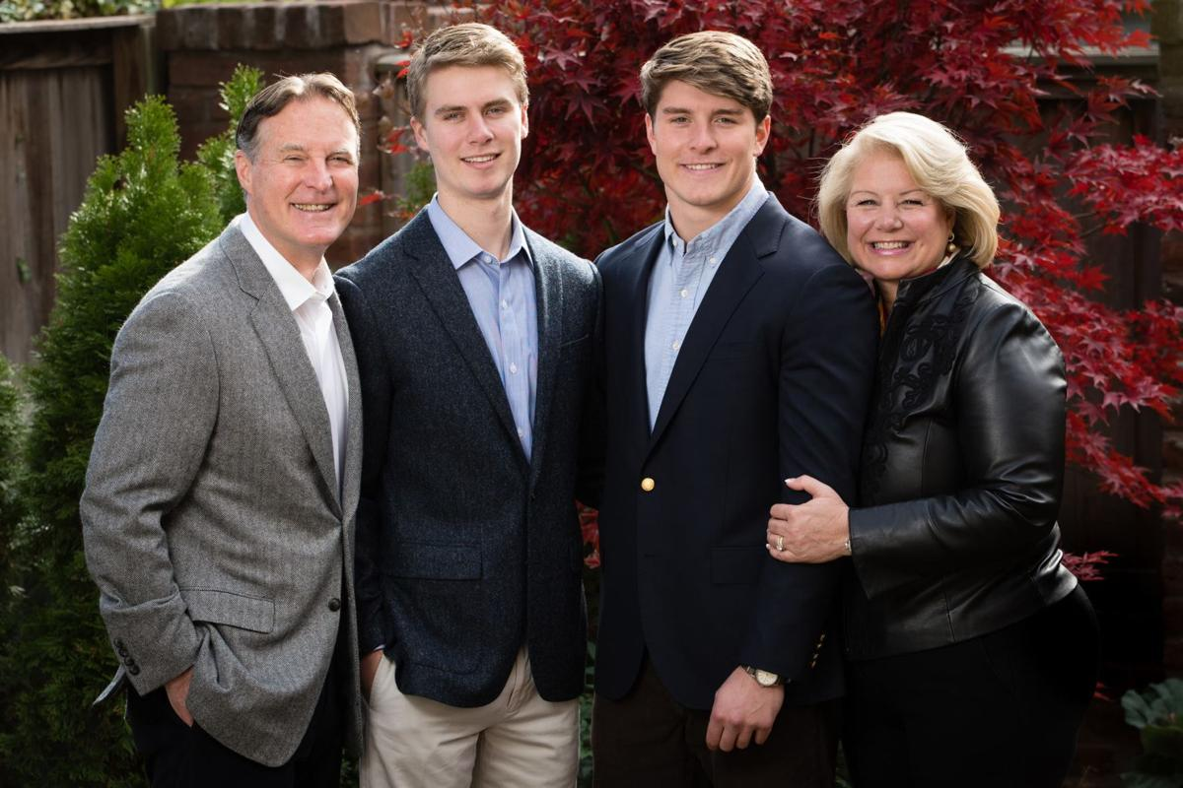
OUR STATE, NATION AND PARTY SUFFERED A LOSS LAST MONTH AND THE HCDP HELPED MAKE A SMALL DIFFERENCE:
With the death of former Indiana First Lady, Susan Bayh, we, as a small Democratic Party felt it was important to contribute to the Bayh family scholarship fund. Our members contributed to our party through our ActBlue account, and we sent a donation last week.
THE BOOK WORM
If you are an avid reader, or come across a book you just love, feel free to send your recommendation to Christine to include in this list. We are thrilled that Pamela Beckford has given us this list. Pamela is an avid reader and we thank her for this contribution to our party!
Maybe at some point, we could have a Zoom or a quick discussion on these books.
“Let the Lord Sort Them” by Maurice Chammah

An in-depth look at the recent history and court cases of capital punishment. While I already have firm beliefs on where I think capital punishment needs to be, this brought up various points of view and how cases were fought and decided (win and lose).

“Trust: America’s Best Chance” by Pete Buttigieg

A look at how we need to start thinking differently if we want to change the future. Trust is what it is going to take to get us there.

“His Truth is Marching On” by Jon Meacham

If you haven’t read this yet, you definitely need to move it up to the top of your list. This is the story of John Lewis and the movement seeking justice for all. It is both riveting and inspiring.

PAGE 6 VOL 2 / ISSUE 3
THOUGHTS FROM THE CHAIR:
So many thoughts, so little time. First, Thank You! We had an incredibly successful and smooth reorganization. Without dedicated Precinct Committee members, we couldn’t have held this vote. We have 39 PC’s and 33 came to the meeting. WOW! Now, we just need to get through the District and State level reorgs and we have it made! We will know in what direction our party is moving and we can plan and work towards that direction, together.
Many of you may have noticed, the flags and signs are finally coming down. There are still a few but have faith, those too shall be gone soon. Have you noticed a change in the air? It is just the Spring warmth and the promise of a vaccinated society, or is it the relief we all feel by not being bombarded daily with “breaking news” and text alerts. Our social media platforms have quieted, along with our minds. Revel in this quiet. Embrace the warmth of the longer sunny days. Renew your soul.
The Honorable Merrick Garland has been confirmed as the next AG. The irony of this is not lost on any of us. As of this writing, it appears the next Covid Relief package will be passed by the House and FINALLY some assistance will be coming to those who have suffered financial strain during this past 8 months. It is estimated that 25% of our children will be lifted out of poverty by this bill. Yes, we do take care of the children! Keep watching non-biased sources of news. It appears there could be some interesting criminal charges coming soon for the previous administration and possibly for some current serving members of Congress for their role in the insurrection. Patience: the wheels of justice turn slowly.
Easter is coming before the next meeting and our next newsletter. For those of you who celebrate, may you have a peaceful and hopeful Easter Sunday. If you are gathering with family and friends, please remember to wear your mask and socially distance when possible. We have almost made if out of the darkness, please don’t let your guard down quite yet.
If you have HBO Max or access to it, and you need a good reminder of what we are doing and why, I highly suggest we all watch or re-watch the West Wing. Why is this crazy woman telling me to watch TV, you ask? Use it to learn. Use it to grow. Fascinating television. My favorite line from the episode we watched last night, “What do you say about a country that protects the very people who are trying to destroy it? ‘God Bless America’”. This line makes me cry. We don’t agree on policy, but we all love this Nation, no matter how we vote.
As always, it is an honor to be your Chair, but most importantly, to call you friends,
Christine

